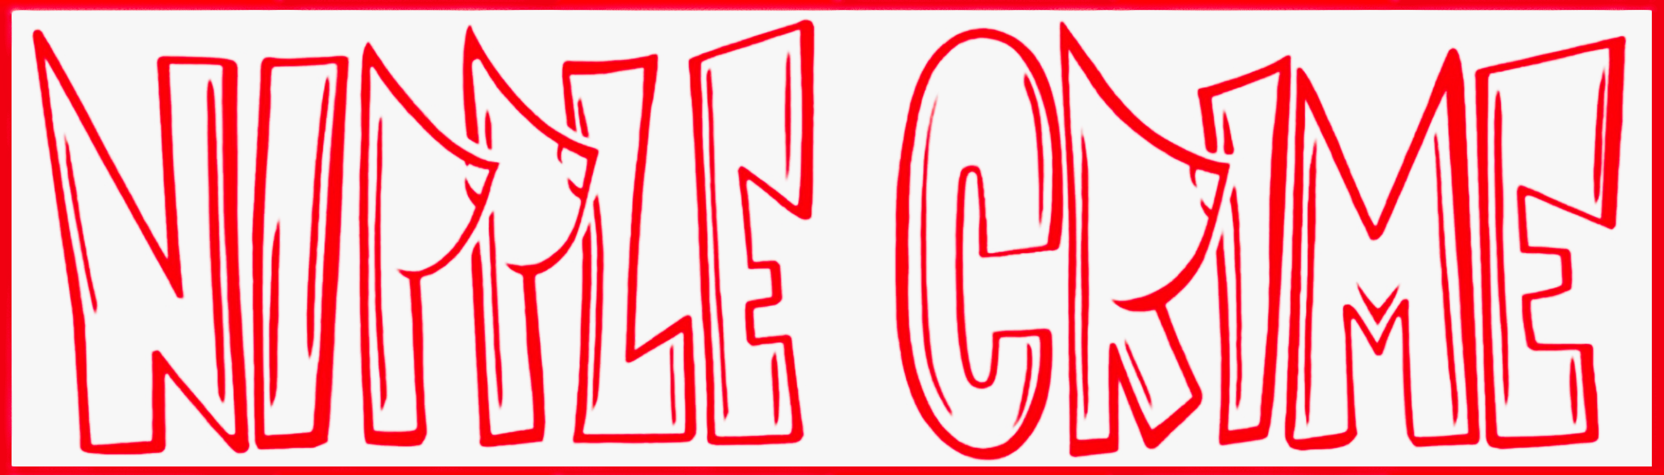

STANDARD OPERATING PROCEDURE
Mutant Vehicle Statement of Intent (BMorg)

SOP Number | Tr4 | Department | Treasurer
Version | 1.0 | Effective Date | 2026-03-03
Last Updated: 2026-03-03

1. Purpose
This SOP documents the annual process for completing and submitting Nipple Crime's Mutant Vehicle Statement of Intent (MVSOI) to the Burning Man Organization (BMorg). The MVSOI is required for all mutant vehicles seeking to operate on the playa and to be considered for the Stewards Ticket Sale allocation. Primary vehicle: SirKiss.

2. Timeline
- MVSOI portal opens: December – January (check burningman.org each year)
- Submission deadline: February – March (verify annually)
- Stewards Sale ticket allocations announced: second week of February
- On-playa DMV licensing: upon arrival at Burning Man each year
- Set calendar reminders at each milestone

3. Submission Steps
- Go to burningman.org > Participate > Mutant Vehicles > Statement of Intent
- Log in using the Nipple Crime account (credentials held by President and Treasurer)
- Select 'Previously Applied — We've applied to bring this vehicle before'
- Complete all required fields — see Section 4 for 2026 reference answers
- Review entries before submitting
- Submit form
- Save / screenshot the BMorg confirmation email for records (see Section 5)

4. 2026 Submission Reference
The following answers were submitted for the 2026 Burn cycle. Update each year as needed.

CONTACT
- First Name: Reece
- Last Name: Dassinger
- Email: Leadership@nipplecrime.org

VEHICLE
- Primary Mutant Vehicle Name: SirKiss
- Most Recent Placed Camp Name: Nipple Crime
- Vehicle Status: Previously Applied — We've applied to bring this vehicle before
- Most Recent Year Licensed at On-Playa DMV: 2025

INTERACTIVITY
- Participatory Aspects: Offering Rides, Music/Sound System, DJ Platform
- Description: We have a sound tech, DJ lineups, crowd management, walkers, and we allow anyone on the art car at all times. We are handicap accessible. We have been in the zip line.

STATUS FOR 2026
- Active / Requesting Access: We plan to bring our Mutant Vehicle in 2026 and would like to be considered for the Stewards Ticket Sale this year.

MULTIPLE VEHICLES
- Registering more than one MV: No

TICKET INFORMATION
- Total crew and passenger capacity of all MVs: 60
- Tickets requested for MV Crew and Support Team: 18
(Note: tickets sold in pairs; MV crew only — theme camp support tickets requested separately through Placement)

CAMPING PLANS
- Part of Another Placed Camp: Team members camping with Nipple Crime (placed theme camp submitting its own placement request)

5. Record Keeping
- Save BMorg confirmation email as PDF
- File location: [Shared Drive > Treasurer > BMorg > MVSOI > YYYY]
- Log: submission date, submitted by, BMorg correspondence, ticket allocation result
- Retain records for minimum 5 years per nonprofit compliance requirements

6. Contacts
- BMorg Mutant Vehicle Team: burningman.org (contact via MV portal)
- President / Primary Submitter: Reece Dassinger — reece@nipplecrime.org
- Art Car Supervisor (SirKiss): Anthony Tolosano
- Treasurer: Isabel Hoy — izhoy@yahoo.com
- VP / SOP Owner: Chris Reddin — creddin1@hotmail.com

7. Revision History
- v1.0 | 2026-03-03 | Initial draft | Chris Reddin

